<http://learningaboutelectronics.com/Articles/Vibration-motor-circuit.php>

(진동모터)   
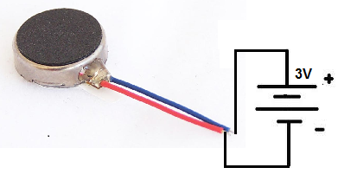

**Parts Needed**

* Arduino Board
* Vibration Motor
* 1N4001 Diode
* 0.1µF ceramic capacitor
* 1KΩ Resistor
* 2N2222 NPN Transistor
* USB Connector

### Vibration Motor Code

The code that vibrates the motor every minute is shown below:   
  
Code to vibrate the motor every minute  
const int motorPin = 3;  
  
void setup()  
{  
pinMode(motorPin, OUTPUT);  
}  
  
void loop()  
{  
digitalWrite(motorPin, HIGH);  
delay(1000);  
digitalWrite(motorPin, LOW);  
delay(59000);  
}  
